AI ASSISTED CODING (ASSIGNMENT-8.1)

Name: K. Chaithra
Roll No: 2503A52711
Batch: 24

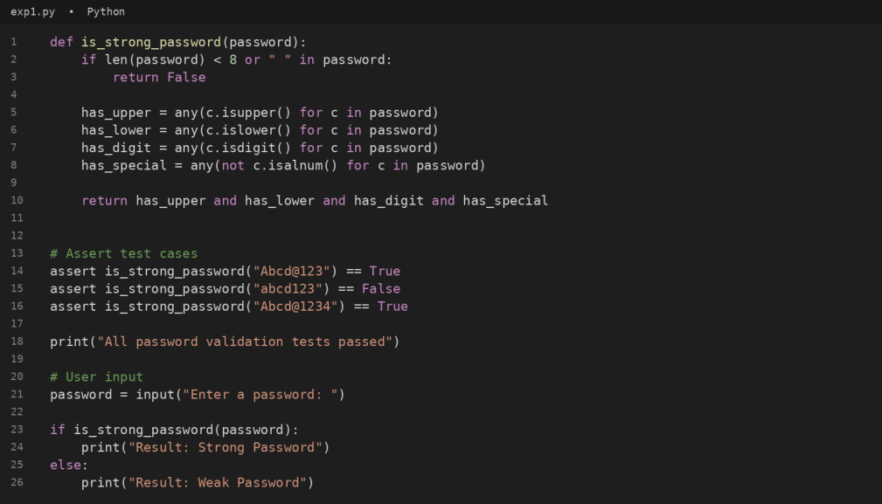
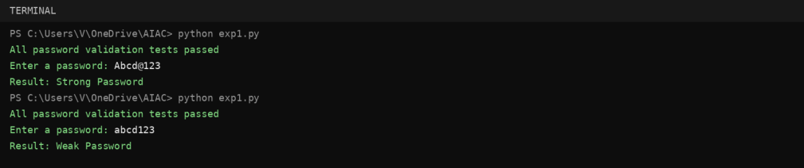

Q1:
Question:
Apply AI to generate at least 3 assert test cases for is_strong_password(password) and implement the validator
function.
Answer:
The Python program below implements the required function/class and verifies it using assert-based test cases.
#code
#output

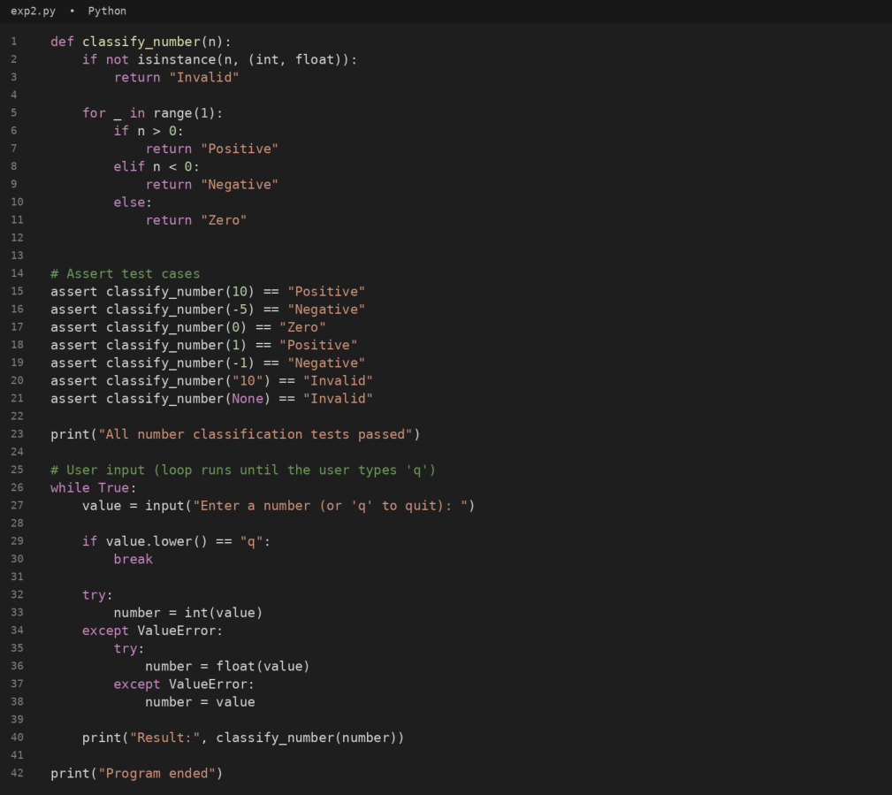

Q2:
Question:
Use AI to generate at least 3 assert test cases for a classify_number(n) function and implement it using loops.
Answer:
The Python program below implements the required function/class and verifies it using assert-based test cases.
#code

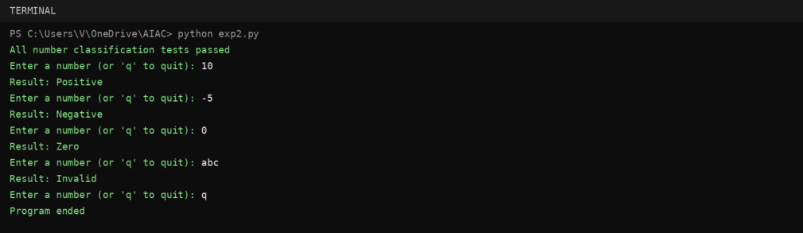

#output

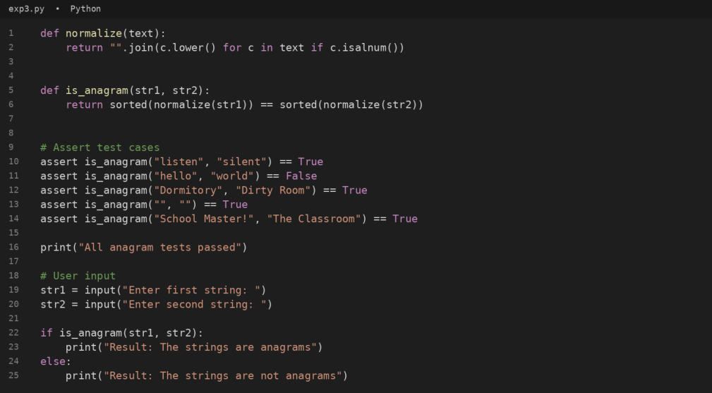
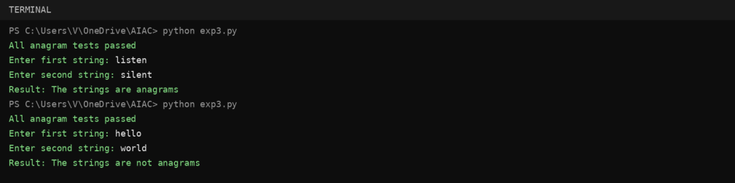

Q3:
Question:
Use AI to generate at least 3 assert test cases for is_anagram(str1, str2) and implement the function.
Answer:
The Python program below implements the required function/class and verifies it using assert-based test cases.
#code
#output

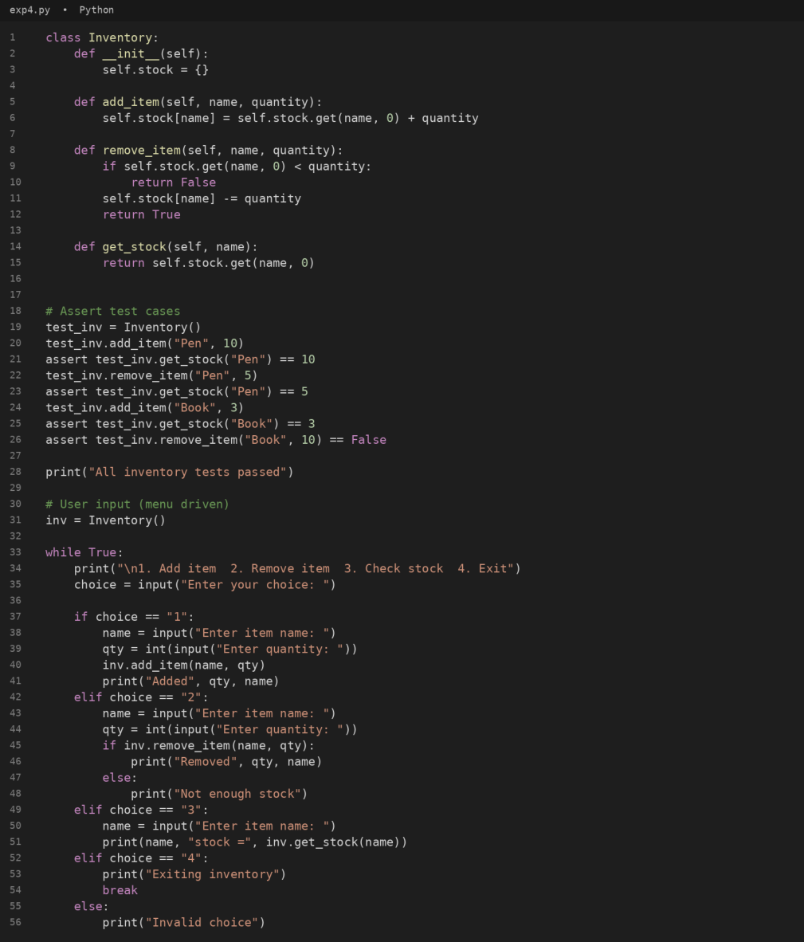

Q4:
QUESTION: Ask AI to generate at least 3 assert-based tests for an Inventory class with stock management.
Answer:
The Python program below implements the required function/class and verifies it using assert-based test cases.
#code

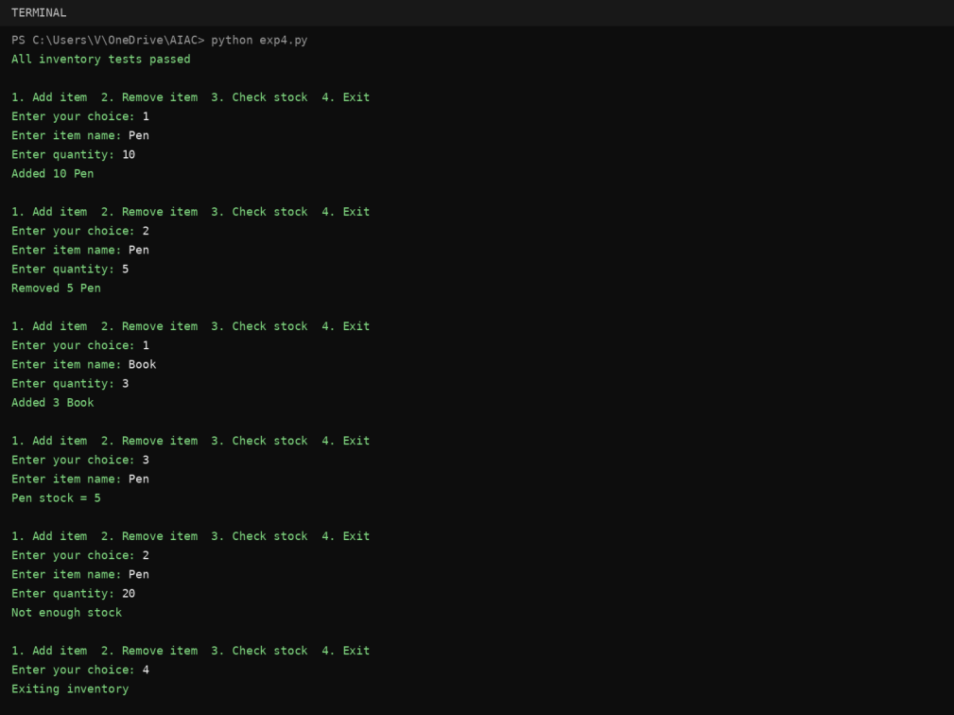

#output

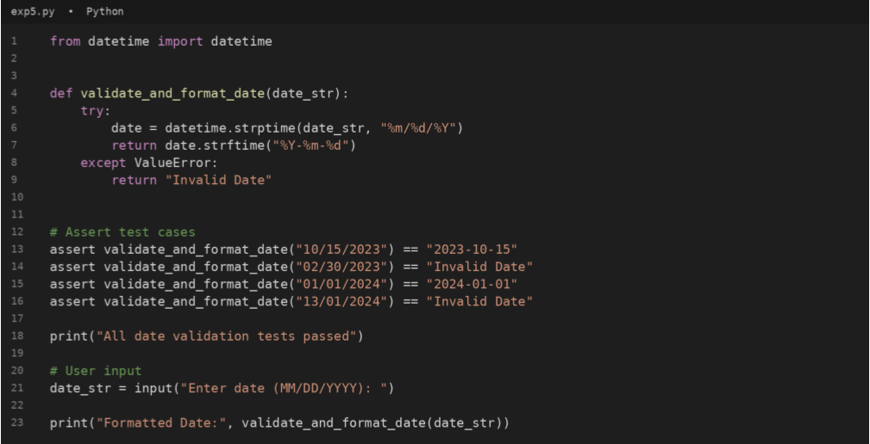
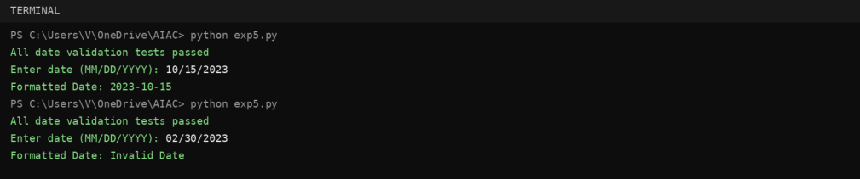

Q5:
Question:
Use AI to generate at least 3 assert test cases for validate_and_format_date(date_str) to check and convert dates.
Answer:
The Python program below implements the required function/class and verifies it using assert-based test cases.
#code
#OUTPUT

